Your name
NOTE: Use this template for your technical description. Follow the organization and heading sequence. Include figures (your own photographs) in the boxes provided for each part.
English 235
Instructor Pedersen
Date of submission
A precise title for paper

Description of Automotive Piston
Use these same headings

General Description (one paragraph)
Three-part definition, function, or background of X
Purpose of X (and audience of this description paper)
Principle(s) of operation (e.g., intake, compression, power, and exhaust)

List of major components/elements/parts
An automotive piston is comprised of the following parts: the piston, compression rings, piston pin, piston skirt, and connection rod. (This type of sentence should be the last sentence of the first paragraph. You should have one paragraph for each part listed in the last sentence.)
Figure title goes above photo
Side View of Piston and Connection Rod

Part are labeled with red lines (no arrows)
Piston Skirt
Piston
Piston Pin
Connection Rod
Compression Rings
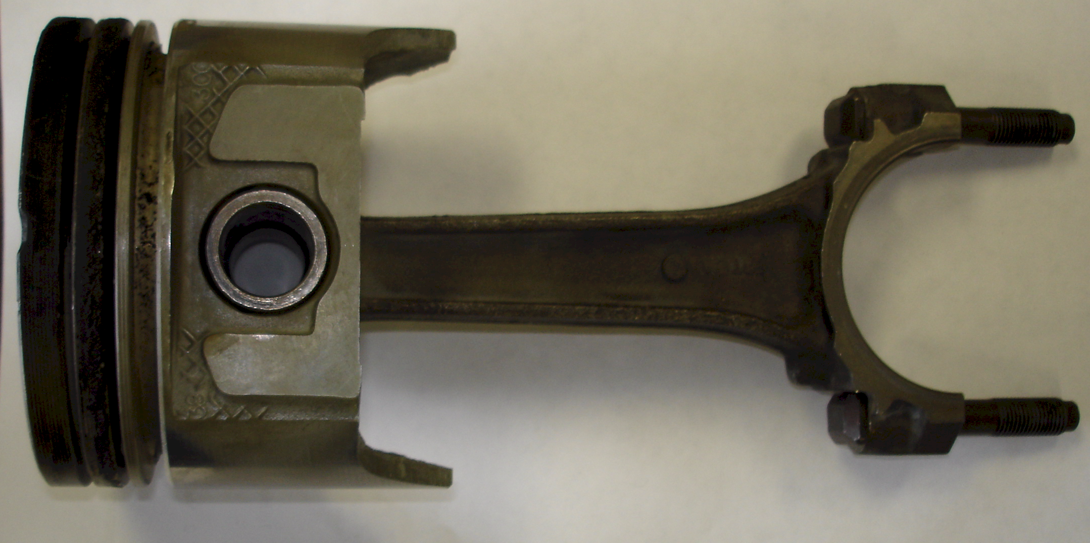

Your original photo (taken with iPhone)

One-sentence figure caption with caption goes below the photo

Figure 1. Most connection rods are made of forged steel or aluminum; compression rings are made of aluminum, forged steel, or cast iron (Hollembeak & Knowles, 2002, pp. 244-246).

Parts and Functions (body of paper, comprised of one paragraph per part)
Piston (This subheading should be the name of the part being described. Each part description should be at least one unified paragraph. Follow this outline. Use paragraph form; do not number each sentence.)
- Description (see figure 2)
  - Shape, dimensions, materials (with visual illustrations)
  - Subparts (if applicable)
  - Function
- Relation to adjoining parts or ideas
- Mode of attachment (if applicable)
Top View of X

Your photo of the part goes here. Import your photo; then remove the border. Labels for each part are optional. See the example below.

Figure 2. One-sentence caption here.

Piston
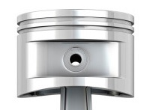

Example figure with title above, photo, and one-sentence caption below

Figure 2. An automotive piston is made of cast aluminum alloy capable of withstanding intense heat and pressure.

Subheading Part Two in Your Descriptive Sequence
1. Description (see figure 3)
2. Shape, dimensions, materials (with visual illustrations)
3. Subparts (if applicable)
4. Functions
5. Relation to adjoining parts or ideas
6. Mode of attachment (if applicable)

Top View of X

Your photo of the part goes here. Import your photo; then remove the border. Labels for each part are optional.

Figure 3. One-sentence caption here.

Subheading Part Three in Your Descriptive Sequence
1. Description (see figure 4)
2. Shape, dimensions, materials (with visual illustrations)
3. Subparts (if applicable)
4. Functions
5. Relation to adjoining parts or ideas
6. Mode of attachment (if applicable)
Profile View of X

Your photo of the part goes here. Import your photo; then remove the border. Labels for each part are optional.

Figure 4. One-sentence caption here.

Summary and Operating Description
A. Summary of overall description
B. Interrelation of parts
C. One complete operating cycle
Below are generic samples of common types of sources used in this assignment.

References

Source from the Internet with author and date

Smith, J. W. (year, Month, day). Title of website or document. Retrieved today’s date, from http://www.thisisasample.html

Smith, J. W. (2013, January, 14). Best technical description in the world. Retrieved April 14, 2013, from http://www.thisisasample.html

Source from the Internet without author or date

Title of website or document. (n.d.). Retrieved today’s date, from http://www.thisisasample.html

Second best technical description in the world. (n.d.). Retrieved April 14, 2013, from http://www.thisisasample.html

Book with one author

Gilles, T. (2004). Automotive service: inspection, maintenance, and repair. (2nd ed.). New York: Delmar.

Book with two authors

Hollembeak, B. & Knowles, D. (2002). Automotive engine repair & rebuilding: classroom manual. New York: Delmar.

